280mm Disc Kit
I am pleased to report that the disc kit I ordered :
Order number: 18-09677-19350
Item ID: 266122059958
Was delivered safely on Monday 13th as predicted. I have now completed the installation, and I thought it might be useful to pass on the following observations:
- I had to use TWO washers between the Al Alloy adaptor and the hub, to get the calliper carrier to align correctly with the disc. This was true O/S and nearside. Total 3 thin washers, 3 of your thick washers +2 intermediate size, from my own stock.
- Different thicknesses of washers were needed (top versus bottom bolts) to align the carrier with even spacing either side of the disc.
- I had anticipated the need to hold the disc tightly against the hub, so I had purchased 4 off M12x1.5 nuts, and I already had plenty of M12 washers.
In the light of points 1 & 2 above, can I suggest that it would be helpful to provide 8 off (or at least 6 off) of each thickness of washer in the kit. I was fortunate in having plenty of left-over 12mm washers from a previous job, but many (most??) purchasers of the kit would not be so lucky.
I used threadlock when finally fixing the brackets to the hubs. As this adaptor should never need to be removed, this seemed a wise precaution, would you agree?
I used the same Torque (85Nm) as specified in the manual, to tighten the adaptor to hub, and the calliper-to-adaptor bolts.
I note that the packaging for the kit you sent was the original packaging for the unmodified VW discs:
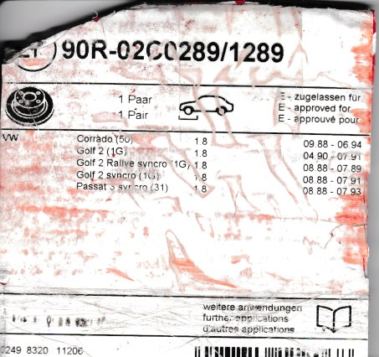

As regards NOT buying 280mm disc conversion for REAR brakes:
My reasoning is that MG offered 304mm dia. discs AND 4-pot callipers on 160hp Fs & TFs, and as a “Sportpack” option on all others. They seemed to think that 240mm brakes were OK with those 304 fronts, so 280mm with std. callipers should be no problem. In addition, a P.O. of my car fitted drill & slotted discs and Green Stuff pads at the rear, so they are already (slightly??) up-rated.

