Immobiliser active (engine will not turn over):
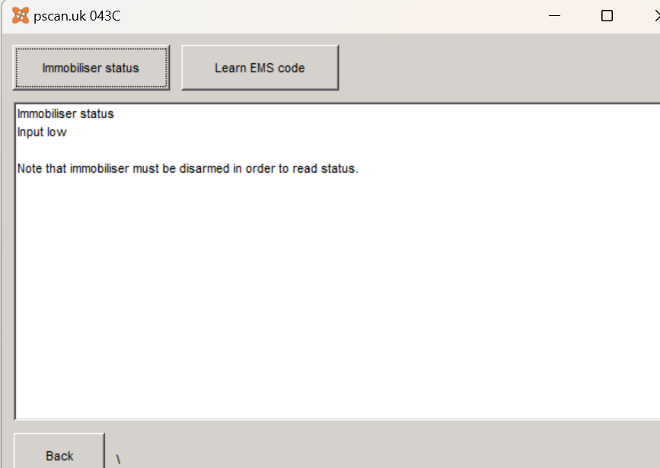
Initially I got this with the immobiliser deactivated (engine turns over)
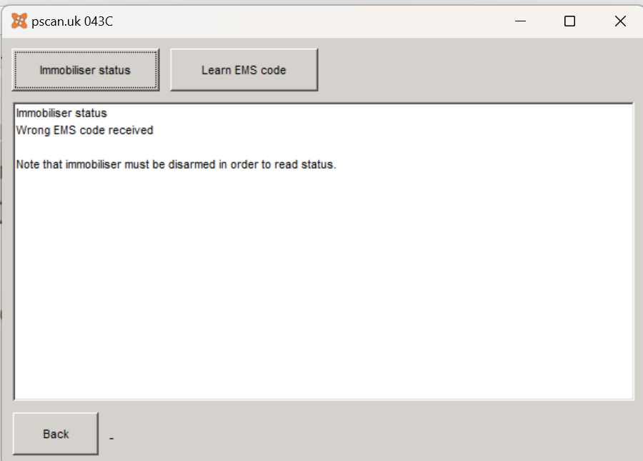
After making Learn EMS code, I achieved this... but still no spark 😤
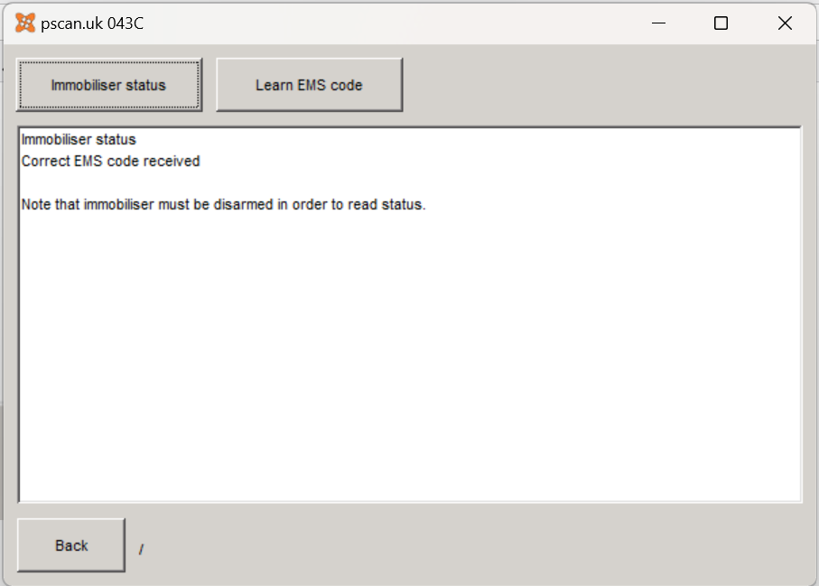
And a last check on the error codes - just one that won't go away but I hope this will not stop a spark 🙄
